Installing RabbitMQ on Windows

RabbitMQ versions support only some versions of Erlang. So depending on the version of RabbitMQ you download/install, please download and install the appropriate/supported version of Erlang.

**For example RabbitMQ 3.8.3 supports Erlang version 21.3 and 22.x (The latest version of Erlang at the time of this writing was v23.0 which is not supported by RabbitMQ 3.8.3 at the time of this writing.**

**Check here before installing Erlang:** <https://www.rabbitmq.com/which-erlang.html>

**Erlang Installation**

* Download the Erlang install from [here](http://www.erlang.org/downloads). Make sure you’ve selected the correct version (32bit or 64bit) as per your machine hardware. At the time of this writing the version (for 64bit) was
* [DOWNLOAD OTP 22.0](http://erlang.org/download/otp_win64_22.0.exe)
* Install it
* After installation, ensure that the Environment paths: **ERLANG_HOME** and **ERLANG_SERVICE_MANAGER_PATH** have been defined and that it has the correct value. This value should be the path of the Erlang install as shown below

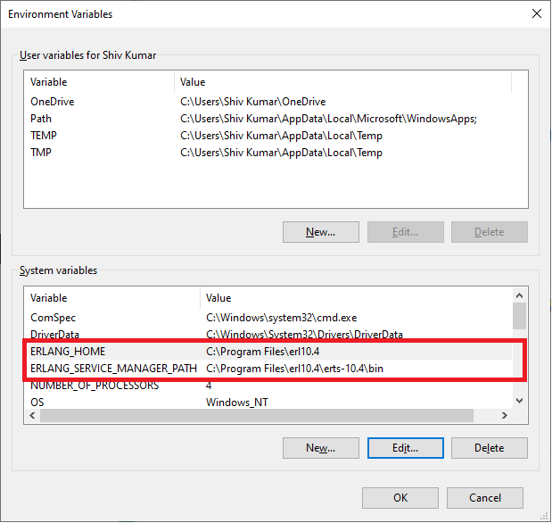

**RabbitMQ Installation**

* Download the RabbitMQ install from [here](http://www.rabbitmq.com/install-windows.html). Make sure you’ve selected the correct version (32bit or 64bit) as per your machine hardware.
* Install it

**RabbitMQ Management UI Installation**

* Open an elevated command prompt
* Navigate to the sbin folder of your RabbitMQ installation. This is typically:

C:\Program Files\RabbitMQ Server\rabbitmq_server-3.6.5\sbin

* Run the following command

rabbitmq-plugins enable rabbitmq_management

* Next, run the following commands in an elevated command prompt
* rabbitmq-service stop
* rabbitmq-service install
* rabbitmq-service start
* Now using your browser, navigate to: <http://localhost:15672>
* Log in using
  + Username: guest
  + Password: guest

**Enabling AMQPS (TLS/SSL) on Port 5671**

* Install OpenSSL from [here](http://slproweb.com/products/Win32OpenSSL.html). Choose the correct version (32bit or 64bit) as per your operating system
* Pick the Win64 OpenSSL v1.0.1t version from the list for 64bit operating systems
* Pick the Win32 OpenSSL v1.0.1t version from the list for 32bit operating systems
* Extract the contents of the RabbitMQCert.zip file to: C:\RabbitMQCert
* Copy the rabbitmq.config file (overwrite if required) to your C:\Users\YourUsername\AppData\Roaming\RabbitMQ folder
* Next, run the following commands in an elevated command prompt
* rabbitmq-service stop
* rabbitmq-service install
* rabbitmq-service start